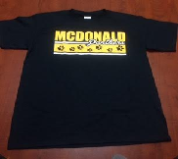

HURRY, HURRY BEFORE THEY’RE ALL GONE!!!
Back by popular demand… NEW T-SHIRTS are available to purchase for your McDonald student and any member of your family. The shirts come in all sizes and are only $10.00!!! All shirts will have the design of “McDonald Panthers!” Everyone can wear their shirt on field trips, field day and/or other McDonald events.
Please select the correct size below and attach $10.00 per shirt. You may pay by cash or check made out to: “McDonald School.”

----------------------------------------------------------------------------------------------------------------------------------------

STUDENT SIZES
XS  (2-4)  _____ | S  (6-8)  _____ | M  (10-12)  _____ | L  (14-16)  _____

Adult  (S)  ____ | Adult  (M)  ____ | Adult  (L)  ____ | Adult  (XL)  ____ | Adult  (XXL)  ____
ADULT SIZES

_________________
_________________
_________________
_________________

